|  |  |
| --- | --- |
|  | **Year 11 General Mathematics Essentials 2018**  **Task 5**  **Application 3 – CAPACITY AND PACKAGING**  **Weighting: 2.5% Marks : 43**  **Name: _____________________ Due Date: _________** |
|  |  |

**PART A – CAPACITY Marks : 20**

**Question 1** (3 marks: 2, 1)

1. Calculate the volume of the milk carton shown in the diagram on the right. Round your answer to the nearest whole.

**5 cm**

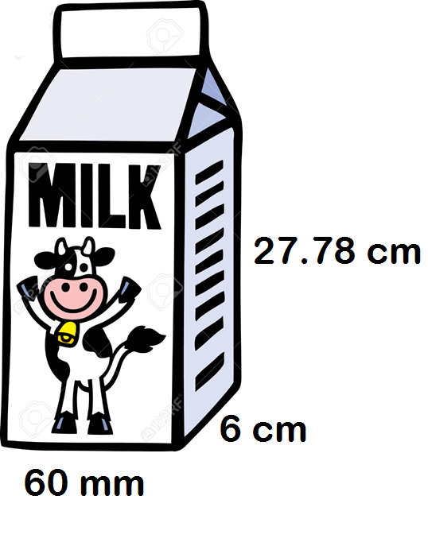

Milk is filled to here.

Show your working.

1. What is the capacity of this milk carton?

**Question 2** (3 marks)

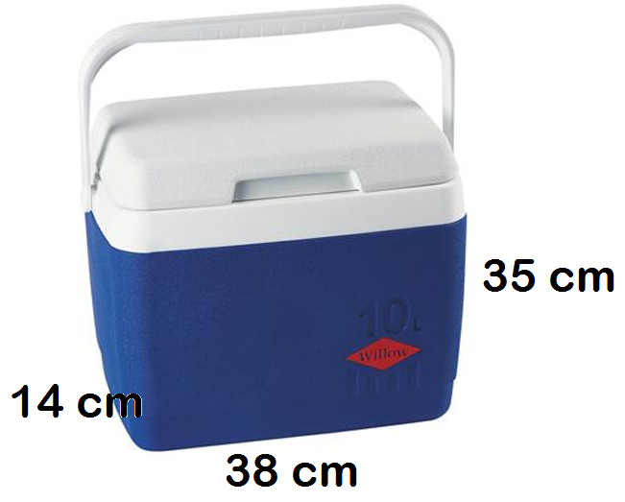The Esky shown is used to carry milk cartons. The internal dimensions of the Esky are given. What is the maximum number of milk cartons can be packed into the Esky at one time?

**Question 3** (2 marks)

If the milk carton holds 5½ serves. How many millilitres is in a serve? Round to the nearest ten.

**Question 4**  (12 marks: 3, 2, 1, 6)

To make the drink called Olim, 5% of the ingredients is milo and 95% is milk.

1. One glass is filled with Olim and has a capacity of 420 mL.
   1. How many mL of the glass would be milo? (2 marks)
   2. If 1 mL = 1 gram, how many grams of milo is required? (1 mark)

1. If a teaspoon holds 5 grams, how many teaspoons of Milo is required to make 1 drink? Round to the nearest teaspoon. ( 2 marks)

1. What proportion of the drink, as a simplified fraction, is milk? (1 mark)
2. John is having a party of 27 guests. Each guest is having one glass of Olim.   
   1. How much milk is required to cater for the guests? (2 mark)
   2. How much milo (in grams) is required to cater for the guests? (1 mark)
   3. How many cartons of milk will John need to purchase to cater for his guests? (2 marks)
   4. If each carton costs $1.75, how much will it cost John? (1 mark)

**PART B – PACKAGING Marks : 23**

**Question 1** (6 marks: 2, 2, 2)

Find the volume of each of the shapes below. Clearly show calculations.

|  |  |
| --- | --- |
|  |  |
|  |  |
|  |  |

**Question 2** (10 marks: 5, 5)

Below is shipping carton along with its dimensions. The volume of this shipping carton is 27 000 cm3.

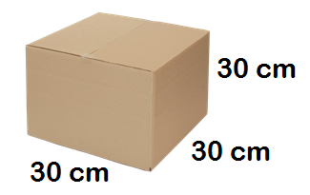

1. A shipping company uses the shipping carton above to transport the Lindt Chocolate boxes shown. (3 marks)

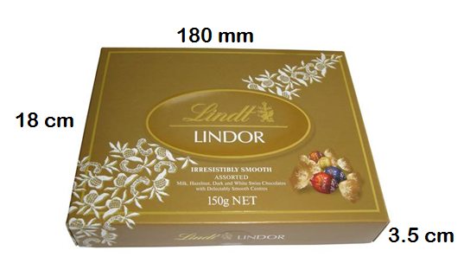

1. Show how the Lindt boxes would be packaged within the shipping carton so that space is not wasted. Draw cross-sectional diagrams of the front, side and top of the shipping carton that show how the Lindt boxes are stacked.

|  |  |  |
| --- | --- | --- |
| **FRONT** | **SIDE** | **TOP** |

1. What is the maximum number of Lindt boxes that can fit into one shipping carton? Show how you have got your answer. (2 marks)
2. Another shipping company uses the shipping carton to transport the Toblerone Chocolate boxes shown. (3 marks)

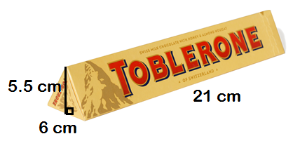

* 1. Show how the Toblerone boxes would be packaged within the shipping carton so that space is not wasted. Draw cross-sectional diagrams of the front, side and top of the shipping carton that show how the Lindt boxes are stacked.

|  |  |  |
| --- | --- | --- |
| **FRONT** | **SIDE** | **TOP** |

* 1. What is the maximum number of Toblerone boxes that can fit into one shipping carton? Show how you have got your answer. (2 marks)

**Question 3 (7 marks: 5, 2)**

Juice boxes are transported in open trays, as shown in the diagram below.

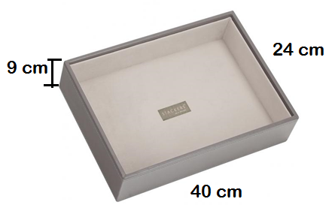

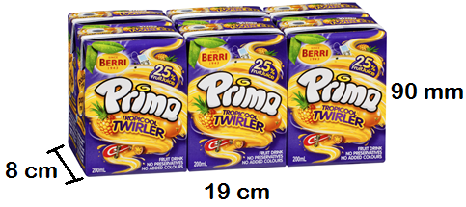

1. A pack of juice boxes, as shown in the picture, contains 6 individual 200 mL boxes within the pack.   
   1. What is the maximum number of juice boxes can be transported within a tray? (4 marks)

* 1. What is the capacity of juice within the tray in litres? (1 mark)

1. 1 millilitre = 1 gram. What is total weight, in kilograms, of a tray of juice boxes?

( 2marks)

End of Investigation